First version

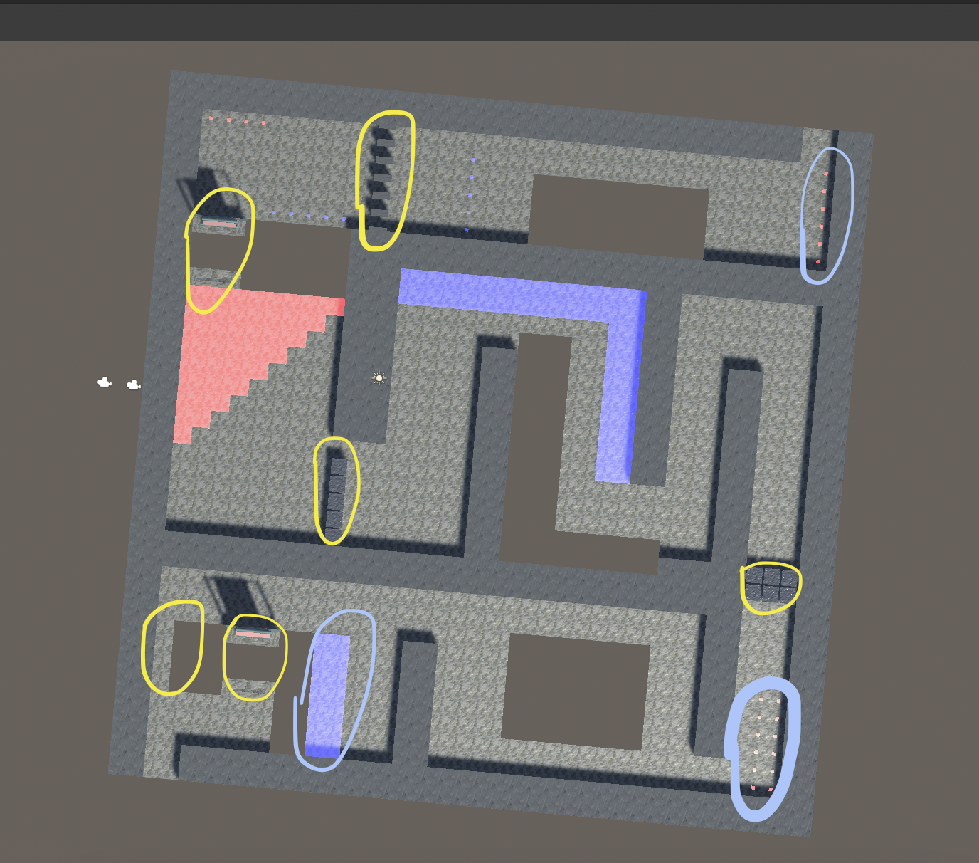

Mechanics used:

1. Bridge \*2
2. Thin wall \*2
3. Heavy weight \* 2
4. Hot area \*1
5. Blue area \*2

Overall explanation:

This map is designed for level 1 player so not all the mechanism is used. The goal for this level is for player to get familar with changing the size of the ball.

There are a few options for the player to change sizes: use the cold/hot area or the red and blue blues.

The player need to shrink the size of the ball in order to go through the thin wall.

The player need to increase the weight of the ball in order to push through the heavy box and the bridge.

Check points:

The yellow circles are the check point that we need to add in order to check if the player has pass the partial challenge.

The blue circles are the check points that we need to add in order to check which of the options that the player used to pass the challenge

Detailed implementations:



This is a special design to encourage the player to be creative and make correct decision for the path in a limited time frame.



This part of the map is giving player options to go through the map in two different ways. If the user is small enough he or she can directly pass through the narrow way. However, if the player is too big, then he or she need to go through the bridge without going back to the hot/cold area to change size.